**Experiment: To study Super position’s theorem.**

**Objective: To verify the Super position’s Theorem.**

**Apparatus:** Virtual using Tinkercad ([www.tinkercad.com](http://www.tinkercad.com/))

**Theory:** Superposition theorem states that - "In a linear, bilateral network, consisting of severalsources, the resultant current in any branch is the algebraic sum of the currents caused by the separate independent sources acting alone replacing all other sources by their respective internal resistances." This theorem when used for evaluating response in a complicated network containing several sources, simplifies the analysis. The theorem is particularly used in case of network, where sources generating voltages or currents of different frequencies are acting simultaneously, considering the effect of individual source independent of others.

**CURCUIT DIAGRAM:**

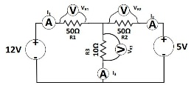

**Procedure:**

1. Connect circuit as shown in diagram on tinkercad workspace. Consider only one voltage source at a time, first 12V.
2. Start the simulation and note down I1, I2 & I3 one by one by connecting current meter in series of resistances R1, R2 & R3. Also note down the voltages across the resistances VR1, VR2 and VR3 by connecting the multimeter in voltage mode in parallel to the resistances.
3. Now consider only 5V and note down I1, I2 & I3 one by one by connecting current meter in series of resistances R1, R2 & R3. Also note down the voltages across the resistances VR1, VR2 and VR3 by connecting the multimeter in voltage mode in parallel to the resistances.
4. Now consider both 12V & 5V to note down I1, I2 & I3 one by one by connecting current meter in series of resistances R1, R2 & R3. Also note down the voltages across the resistances VR1, VR2 and VR3 by connecting the multimeter in voltage mode in parallel to the resistances.

1. Now compute the same through analytical method by calculating the currents and voltages for all the modes and tabulate the results. Compute the percentage error if any.

**Observation Table: -**

|  |  |  |  |  |  |  |  |  |  |
| --- | --- | --- | --- | --- | --- | --- | --- | --- | --- |
| **CURRENT** | **EXPERIMENTAL** | | |  | **Theory** | |  |  |  |
|  |  |  |  |  |  |  |
| **I/P DC VOLTAGE** | | |  |  |  |  |
| **&** |  |  |  |  | **%Error** |  |
|  |  |  |  |  |  |  |  |
| **12V** | **5V** | **(12V+5V)** | **12V** | **5V** |  | **(12V+5V)** |  |
| **VOLTAGE** |  |  |  |
|  |  |  |  |  |  |  |  |  |
|  |  |  |  |  |  |  |  |  |  |
| **I1** | 0.206 | -0.0143 | 0.1917 | 0.206 | -0.0143 |  | 0.1917 | NONE |  |
| **I2** | -0.0343 | 0.857 | 0.0514 | -0.0343 | 0.857 |  | 0.0514 | NONE |  |
| **I3** | 0.171 | 0.0714 | 0.2424 | 0.171 | 0.0714 |  | 0.2424 | NONE |  |
| **VR1** | 10.3 | -0.714 | 9.57 | 10.3 | -0.714 |  | 9.57 | NONE |  |
| **VR2** | -1.71 | 4.29 | 2.57 | -1.71 | 4.29 |  | 2.57 | NONE |  |
| **VR3** | 1.71 | 0.714 | 2.43 | 1.71 | 0.714 |  | 2.43 | NONE |  |

**Circuit diagram on Tinkercad:**

**DIAGRAM FOR 12V:**

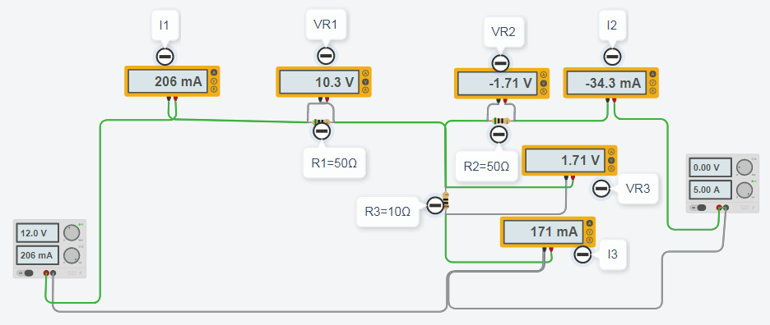

**DIAGRAM FOR 5V:**

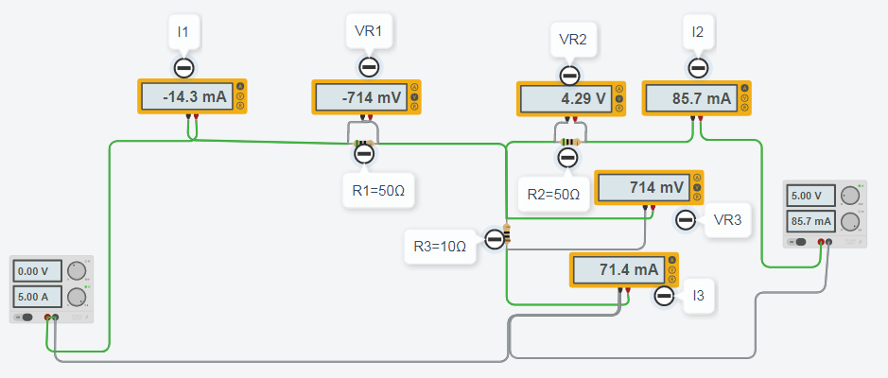

**DIAGRAM FOR 12+5V:**

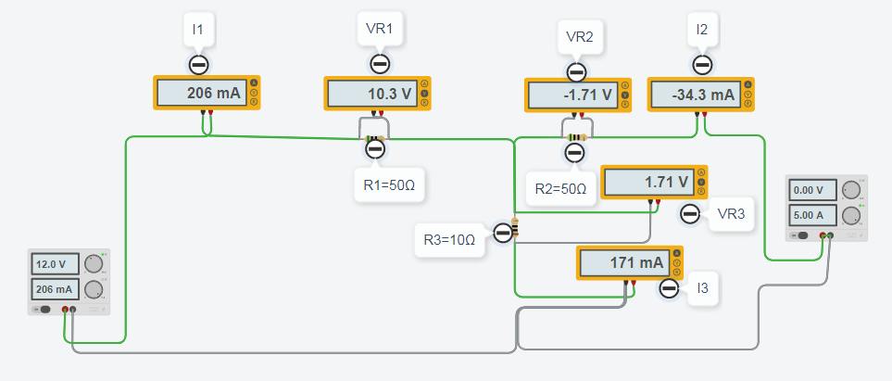

**CALCULATIONS :**

**FOR 12V:**

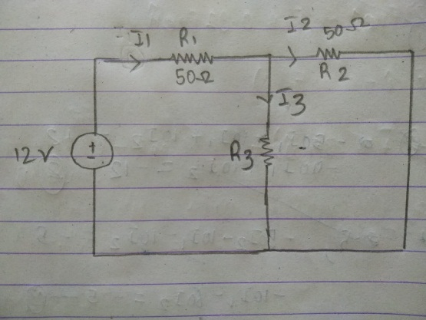

Here, R2 and R3 are given parallel so the resistance req will be:

**Req**= (R2 * R3) / R2 +R3

= (10*50) / 10 + 50

= 8.3 ohm

Also Req is given in series with R1 so,

**Req1** = Req + R1

**Req1**=50+8.3 = 58.3

Now **I1** = 12/58.3 = **0.206 A**

Using the current distribution law we obtain

**I3** = (R2 / R2 + R3) * I1

=(50/60)*0.206

= **0.172 A**

**I2** = I1 – I3

= 0.206-0.172

= **0.034 A**

Now, the voltages across all resistors are:

**V1** = 50*0.206

= **10.3 V**

**V2** = 50*0.034

= **1.7 V**

**V3** = 10*0.172

= **1.72 V**

**FOR 5V:**

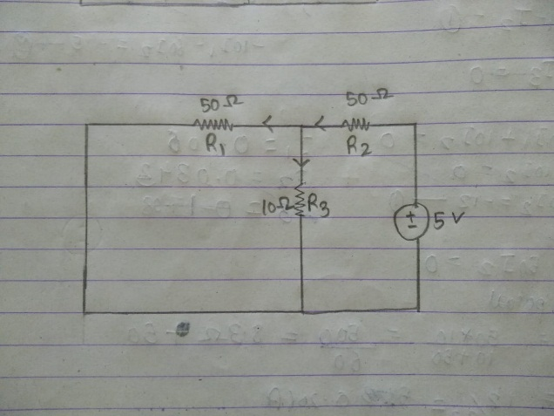

Here, R1 and R3 are parallel to each other

**Req = (R1 * R3) / (R1 + R3)**

= (10 * 50) / 10 + 50

= **8.3 ohm**

Also **Req** is in series with R2 so,

**Req1**= Req + R2

=50 + 8.3

= **58.3**

**I2** = 5/58.3

= **0.0857 A**

Using current distribution law we can obtain:

**I3** = (R1 + R3) * I2

= (50 / 60) * 0.0857

= **0.0714 A**

**I1 =** I2 – I3

= 0.206-0.172

= **0.0143 A**

Now, voltages across all resistors is:

**V1** = I1 * R2

= 50 * 0.0143

= **0.715 V**

**V2**= I2 * R2

= 50 * 0.0857

= **4.285 V**

**V3** = I3 * R3

= 10 * 0.0714

= **0.714 V**

**FOR 12+5V:**

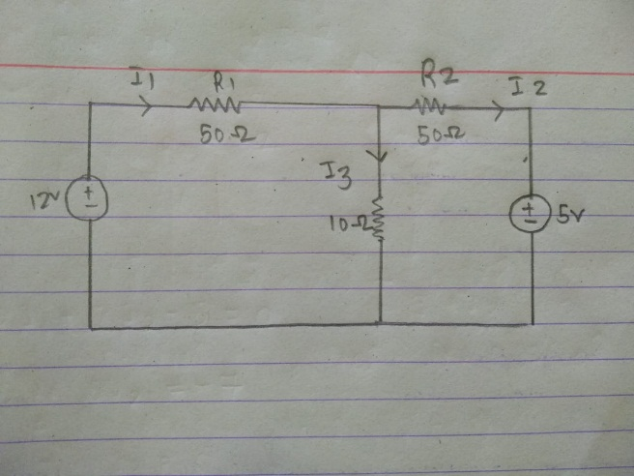

Equation:

I1+I2 = I3

Now applying nodal method

(12- Va) / 50 + (5 - Va ) / 50 = Va / 10

12 - Va + 5 - Va = 5Va

7Va = 17

Va = 2.43 V

**V1** = 12-2.43 = **9.57 V**

**V2** = 5-2.43 = **2.57 V**

**V3** = 2.43-0 = **2.43 V**

**I1** = 9.57/50 = **0.1914 A**

**I2** = 2.57/50 = **0.0514 A**

**I3** = 2.43/10 = **0.243 A**

**Conclusion:**

After theoretically calculating the the values of current and voltage across all resistors in the circuit when individual sources 12V and 5V act and adding up the respective values of current and voltages, we find them numerically equal or close to the values obatained when 12V and 5V act in the circuit together. Hence, **SUPER POSITION THEOREM IS VERIFIED**.

***********************************************************************************